Q1

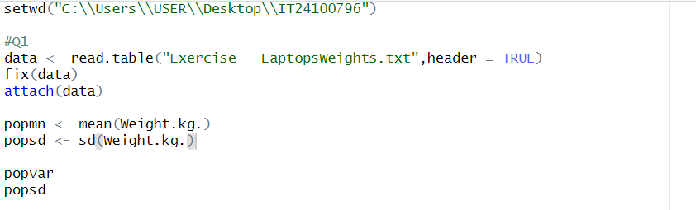

Q2

Q3

